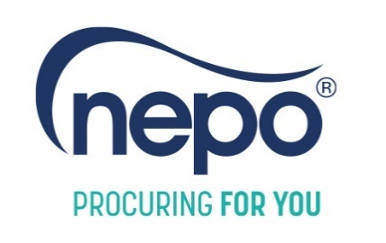
Complaints & Compliments Procedure

Introduction
This document sets out what you should do if you would like to provide feedback on a service that NEPO has provided.
By giving your views on our service you can help the organisation to:

- Put things right if we have made mistakes
- Continuously improve our services and make sure we do not repeat mistakes
- Build on good practice and recognise the achievements of NEPO employees
NEPO aims to provide the best possible service to stakeholders. The Complaints & Compliments Procedure is guided by the following principles:
- Your feedback will not negatively affect the service that NEPO provides to you or future working relationships. Any person making a complaint will be treated with courtesy and respect at all times.
- Personal information given in your correspondence with NEPO will be treated in accordance with the Data Protection Act 2018 and UK GDPR.

Providing a compliment
Compliments are valuable, welcome and important as they enable NEPO to:
- Understand whether our service is meeting/exceeding stakeholders’ expectations
- Provide positive feedback to our staff
- Influence our organisational development
If you would like to provide a compliment on any aspect of NEPO’s activity, please contact us using the following information:
- Email: hello@nepo.org
- Phone: 0191 638 0040
- Post: NEPO, Northern Design Centre, Abbots Hill, Gateshead, NE8 3DF
Your feedback will be recorded and shared with NEPO team members and any relevant parties
Making your complaint
Please use the contact information below to make your complaint:
- Email: hello@nepo.org
- Phone: 0191 638 0040
- Post: NEPO, Northern Design Centre, Abbots Hill, Gateshead, NE8 3DF
Please tell us:
- Your name (optional – you can remain anonymous if preferred)
- Your preferred contact method for a response i.e. by phone, in person, or in writing (including by email)
- Details of your complaint or compliment
- What you would like us to do

What will NEPO do on receipt of a complaint?
Step 1: Problem Solving
On receipt of your complaint, NEPO will try to sort out the issue quickly and informally by providing information or taking any appropriate action.
Step 2: Investigation
If we cannot resolve your complaint immediately, we will send you an acknowledgment within three working days that tells you:
- Who is dealing with your complaint;
- What NEPO will do; and
- How long we will take to deal with it. This is normally within twenty (20) working days. If this is not possible, we will tell you why and give you a date by which you can expect a response.
Step 3: Resolution
Once the investigation is complete, you will receive the outcome in writing from NEPO. NEPO may resolve a complaint by offering an apology, making a goodwill gesture or providing appropriate compensation.

NEPO shall maintain a full and complete record of your complaint, including relevant details such as the dates a complaint was received and responded to.
Referring your complaint to the Local Government Ombudsman
If you are not happy with the way your complaint is being handled you can contact the Local Government Ombudsman (LGO). You can refer your complaint at any stage of your complaint with NEPO.

There are many ways to contact the LGO, please refer to their website at www.lgo.org.uk/contact-us

Referring you complaint to the Energy Ombudsman
Where complaints are regarding NEPO’s role as a third party intermediary for energy supply contracts, you may escalate your complaint to the Energy Ombudsman. You can refer your complaint to the Energy Ombudsman if NEPO is unable to resolve your complaint directly, or if the issue remains unresolved for over eight (8) weeks.
The Energy Ombudsman’s service is impartial and free to use.
Please use the contact information below:
- Post: Energy Ombudsman
P.O. Box 966
Warrington
WA4 9DF

- Phone: 0330 440 1624
- Email: enquiry@energyombudsman.org

A copy of this Complaints and Compliments Procedure can be emailed or posted to you without charge

